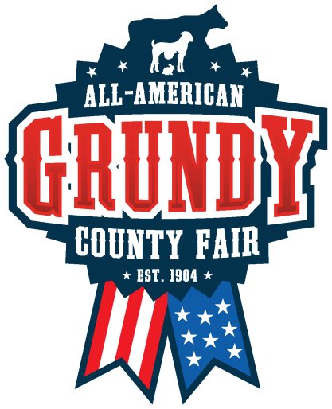
Grundy County Fair Grandstands Project
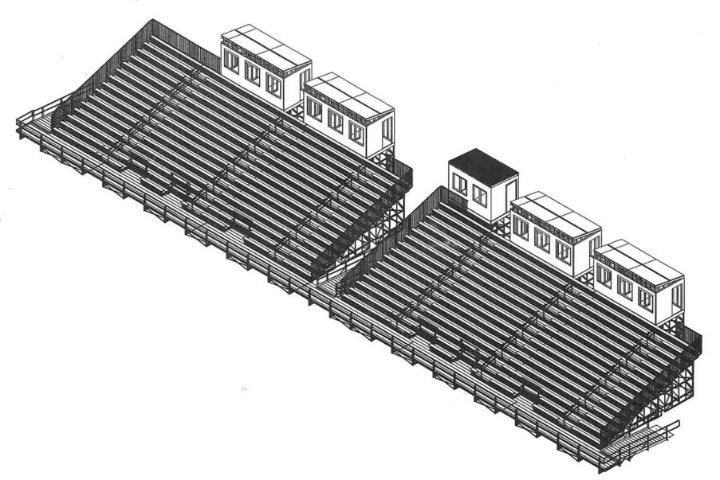
Get your name on a piece of the brand new Grundy County Fair Grandstands! This project will be a reality for the 2020 Grundy County Fair! We have all types of sponsorship levels and would love to have your name on a piece of the new Grandstands! Help us reach our goal of $200,000. Thank you!! Every donation/sponsorship helps!

General Donations/Sponsorships:
$25 Seat Sponsor: (Name goes on a donor sign located at the Grandstand Entrance permanently)
$1,000 Row Sponsor: (Name on plaque proudly displayed on a row in the Grandstands permanently)
$10,000 Section Sponsor: (Name largely on display on the section of your choice for 5 years)
$25,000 Press Box Sponsor: (Name/logo filling the back side of your press box permanently)

Thank you for your interest in making the new and improved Grandstands a reality! Donations of $25 and $1,000 are permanent and will remain with donor name on a plaque for $1,000 or donor name on the $25 banner will be permanent. All $10,000 donations can be placed on a five-year contract with the option of paying in yearly installments of $2,000 each year for the five year increments. All donors will have the first option to renew when their five-year contract is up for renewal. Press Box Sponsors can also pay on a five-year contract and their box will be permanent. Other costs might arise if they change their logo and advertising needs updating.
Donors of $1,000+ will be publicized in a thank-you ad and included in marketing materials during their five-year contract. Donations can be accepted via mail, handed to a board member or online.
Any donation $1,000+ gets logo on the Donor Thank You Banner for the duration of their five-year-contract.

Thank you from the Fair Board: Jared Gutknecht, Kyle Dudden, Jodi Michael, Jerry Schmidt, Brandon VanLoh, Jeff Greiner, Richard Benson, Curt Kyhl, Logan Clark, Katrina Hemann, Jody Noteboom, Pat Brown, Bryan Moeller, Jason Steinmeyer, Justin Lynch, Kurt Steckelberg, Brian Feldpausch, Ally Graves, Luke Kjormoe, Clay Geitter & Derek Noteboom.

Grandstands Donation Form

Name/Business Name:________________________________________

Address:___________________________________________________

City:______________________________________________________

State:_____________________________________________________

Zip Code:__________________________________________________

Phone Number:_____________________________________________

Email:____________________________________________________

Donation Amount:___________________________________________

A conformation number and a receipt will be given to you for your records.

Thank you for support of the Grundy County Fair!

